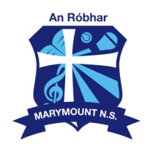
Marymount N.S. The Rower.

Notification regarding the Board of Management’s review of the
Child Safeguarding Statement

To: School Community Marymount N.S.

The Board of Management of Marymount N.S. wishes to inform you that:

- The Board of Management’s annual review of the school’s Child Safeguarding Statement was completed at the Board meeting of 06/02/2020.

- This review was conducted in accordance with the “Checklist for Review of the Child Safeguarding statement” published on the Department’s website www.education.ie.

Signed : Date : 06/02/2020

Chairperson, Board of Management

Signed : 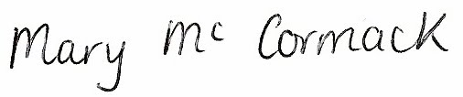 Date : 06/02/2020

Principal / Secretary to the Board of Management

